Day 4 Learning
- What is Delta Lake?
Delta Lake is an open-source storage layer that brings ACID transactions (Atomicity, Consistency, Isolation, Durability) to big data workloads on top of existing data lakes like Apache Spark and Hadoop. It was originally developed by Databricks.
Here’s what makes Delta Lake important:
- Key Features
- ACID Transactions
Ensures data reliability and consistency even in distributed environments.
- Schema Enforcement & Evolution
Prevents bad data from being written and allows schema changes over time.
- Time Travel
You can query older versions of data using versioning (great for auditing and debugging).
- Unified Batch & Streaming
Handles both real-time streaming and batch data in the same table.
- Scalability
Works with petabyte-scale data on cloud or on-premise.
- How It Works
- Delta Lake stores data in Parquet format and maintains a transaction log (called _delta_log) that tracks all changes.
- This log enables features like rollback, versioning, and concurrent writes.
- Common Use Cases
- Building data lakes with reliability.
- Implementing data pipelines for analytics and machine learning.
- Supporting streaming ingestion with batch analytics.
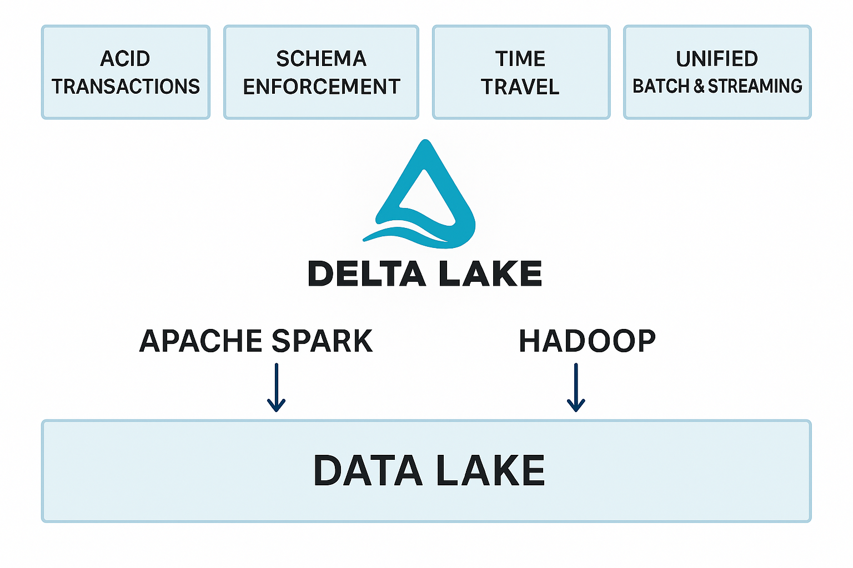
- ACID transactions
ACID transactions refer to a set of properties that guarantee reliable processing of database transactions. The acronym stands for:
- A – Atomicity
- A transaction is all or nothing.
- Either all operations in the transaction succeed, or none do.
- Example: If you transfer money between accounts, both debit and credit must happen together.
- C – Consistency
- The database moves from one valid state to another.
- After a transaction, all rules (constraints, triggers) remain satisfied.
- Example: If a column must be unique, the transaction cannot violate that rule.
- I – Isolation
- Transactions run independently of each other.
- Intermediate states of a transaction are not visible to other transactions.
- Example: Two users updating the same record won’t interfere with each other.
- D – Durability
- Once a transaction is committed, it is permanent.
- Even if the system crashes, the changes remain (thanks to logs or backups).
- In Delta Lake, ACID ensures:
- Reliable writes to your data lake.
- No partial updates or corrupt files.
- Safe concurrent reads/writes for streaming and batch jobs.

- Schema enforcement
Schema enforcement is a feature that ensures the data being written to a table follows a predefined structure (schema). In other words, it prevents bad or incompatible data from being inserted into your dataset.
- How It Works
- When you define a table with specific columns and data types (e.g., id: INT, name: STRING), schema enforcement checks every incoming record.
- If the incoming data does not match the schema (wrong data type, missing columns, extra columns), the write operation fails.
- Why It’s Important
- Prevents data corruption in large-scale systems.
- Ensures data quality and consistency across pipelines.
- Avoids downstream errors in analytics and machine learning.
- In Delta Lake
- Delta Lake enforces schema at write time.
- It also supports schema evolution, meaning you can add new columns or update the schema safely when needed.
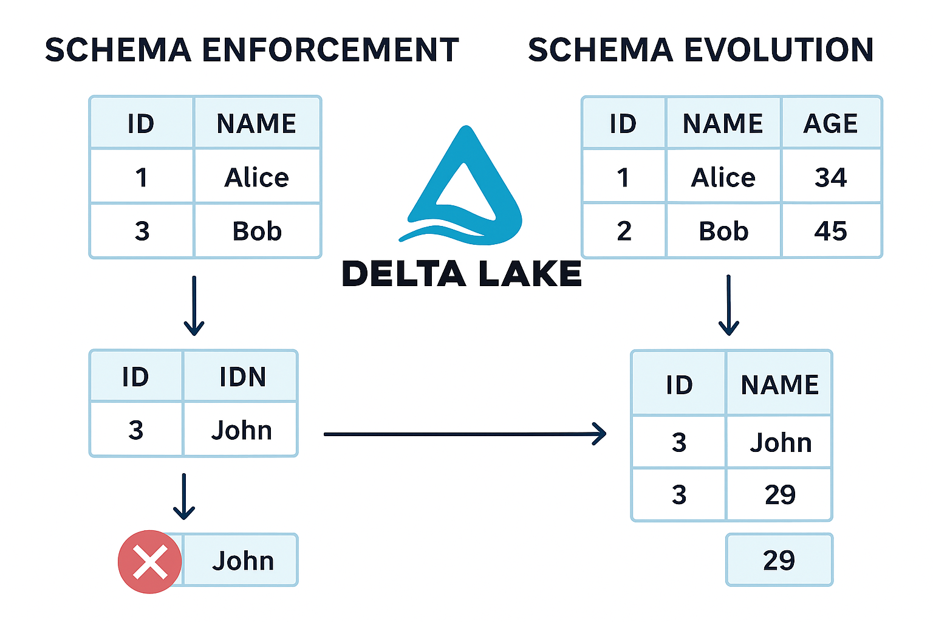

- Delta vs Parquet
✅ Parquet
- What it is:
A columnar storage format optimized for analytics.
- Features:
  - Highly efficient for read-heavy workloads.
  - Supports compression and encoding for performance.
  - Schema is stored in the file metadata.
- Limitations:
  - No ACID transactions.
  - No versioning or time travel.
  - Hard to manage concurrent writes.
  - No built-in schema enforcement beyond basic metadata.

✅ Delta Lake
- What it is:
A storage layer built on top of Parquet that adds reliability and advanced features.
- Features:
  - ACID transactions (safe concurrent writes).
  - Schema enforcement & evolution.
  - Time travel (query old versions).
  - Transaction log (_delta_log) for consistency.
  - Works with batch + streaming seamlessly.
- How it works:
Data is stored in Parquet files, but Delta adds a transaction log to track changes.
- Summary Table
Feature | Parquet | Delta Lake
Storage Format | Columnar | Columnar (Parquet)
ACID Transactions | ❌ | ✅
Schema Enforcement | Basic | ✅
Schema Evolution | Limited | ✅
Time Travel | ❌ | ✅
Streaming Support | ❌ | ✅

